

De Guzman, Roger Arthur William Alejo

**Leader**

Calderon, Alex Joshua

Delos Reyes, Cristian AJ

Elasin, Ralph Wendell Maramba

Sebastian, Edmark

Tinaliga, Victor Philip

**Members**

ITE 351 - BLK 4

**E-Cater Mo!**

Multi-Platform E-Commerce Systems for

Inquiring Food Catering Services via Online

# EXECUTIVE SUMMARY

Embed Company is dedicated to offering unique solutions to specific industrial concerns. We are open, dependable, multicultural, effective, and sympathetic. We enjoy coming up with novel ideas that could use technology to address societal issues. We are also ready for novel changes in this ever-changing industry, which is always evolving. Although the company is still young and new, it is not being underestimated. We offer cutting-edge solutions with excellent business practices and little upkeep. Embed Company has the ability to compete with many industrial rivals and can maintain their position to have a positive impact on society. The only address available for our location is online. We have a website that describes who we are as a company, what we do, the services we offer to clients, and our vision and mission.

# BUSINESS IDEA

Living in the era of technology, when the use of technology has made all communications, transactions, transportation, and other types of daily engagement tasks easier. The field of information technology is always evolving and changing dramatically. Among many other things, technology has made it easier to travel, establish cities, and cultivate crops, effectively connecting all nations, fostering globalization, and facilitating the expansion of economies and the conduct of business. In the end, technology has improved human life from antiquity to the present by resolving issues with daily living and making a variety of activities simpler. Although technology has had some unfavorable effects on society as a whole, there may be more positive effects than bad ones. These effects have eased many people's lives and provided many with the resources, information, and tools they need to lead better lives. These effects have had a significant impact on the education, transportation, agriculture, and other sectors of global society.

Our business plan “E-Cater Mo!” provides a goal to develop a local-based (specifically for the Philippines) mobile application and a future functional website that can help food caterers promote their services by using the platforms, and also to help users find a food catering service for their events, gatherings, and etc. By paying our advertising fees, caterers can also promote their services. Users can search for the kind of cuisine they want for their occasions as well as find nearby food catering businesses. For this business plan, we want to make this easier, more efficient, and more convenient for users to communicate with food caterers. Since technology development is becoming the standard in the majority of nations, we wish to benefit from it.

# BUSINESS FORM

**Limited Liability Company or LLC** is atype of business structure that someone can choose when they're starting a business. This type of structure protects most of an owner's personal assets, and the business's income is passed through to the owners' personal income. Using Limited Liability Company for E Cater Mo! Application and a future functional website, help on not subject to double taxation. It can meet the Return of Investment (ROI) in a short period of time. Since E – Cater Mo! Is a multi-member LLC.

**Benefits of LLC**

* **Tax Advantages of an LLC**

1. **Single-member LLC -** the IRS ignores the business structure and taxes you like it would an individual.
2. **Multi-member LLC -** it does not pay any income taxes, and all the profits are pass-through to the members, who then pay the IRS on their individual tax returns.

* **Protects personal assets** - Owner’s personal financial assets aren’t in danger if the LLC goes into debt or is sued.
* **Management Flexibility -** the LLCs have the option of manager- or member-managed arrangements. Member-managed refers to a firm where the members actively participate in management. In a manager-managed LLC, the members give a manager, who may or may not be a member, control over the company. In this scenario, some members—or all—might choose a more passive investing approach.
* **Less Paperwork** -LLCs are not required to have a board of directors, keep meeting minutes, or hold shareholder meetings.

# BUSINESS MODELS

Business models are an organization's strategy or formula for generating, distributing, and capturing value for its stakeholders. Business models are essential to a company's potential to prosper, both now and in the future, especially when it is the first to market with a novel good or service. A business model is also your company's strategy for generating revenue. It explains how you provide value to your customers at a reasonable price. Describe your target market, the goods or services you intend to sell, and any charges that may be necessary. In essence, they assist young, developing businesses in luring capital, hiring talent, and inspiring management and personnel. Established companies must continuously alter their business models if they are to stay abreast of emerging trends and problems.

The E-Cater Mo system will assist customers in finding a food catering service for their events as well as assist food catering companies in marketing their services through the usage of the aforementioned platforms. We are concentrating on the marketplace, crowdsourcing, brokerage, and pay-as-you-go business models. We believe that this is the finest strategy to make money from our system because it will help us have a higher income.

First, we will be focusing on the Marketplace. As stated, the marketplace allows sellers to list items for sale and provide customers with easy tools for connecting to sellers, our system will be listing the possible catering services that are available in their area and we will be advertising different kinds of catering services that they prefer. This will include the fee to their services and the food that they want and on what kind of event that they will hold. This is like Shopee, but instead, our system is offering catering services that they prefer to trust in the events that they will hold.

Second is Crowdsourcing. Our system will bring a large number of people to contribute content in our system and these are the caterers that are willing to post content about our service or system to advertise their food services. We will use crowdsourcing as an advertisement, not only advertising their catering services in our system that the caterers will also gain services from, but also advertising it to other people or businesses to gain consumers.

Third is Brokerage, where we connect buyers and sellers and help them facilitate a transaction. Our mobile application will have a chat page that will help the caterers or the client to communicate with each other and manage what type of foods that will be served or what kind of event will be held. And also, this will help them to connect with each other while waiting for the event and if ever something might go wrong or some changes will be requested. Access to Excess can also apply in our system that is similar to Brokerage, because we are not only simply connecting the caterers to the clients, but we also create an excess supply of a service to them. We charge a transaction fee to end users (around 2 percent) for it to cover payment gateway fees by the service providers (such as GCash / PayPal / Credit Cards), and through the service commission that may vary from 20%-30%.

And lastly is Pay-as-you-go. This is when clients get charged for the actual usage at the end of a billing period, in which the clients pay for the costs of something when they occur rather than before or afterwards. Our system offers a Pay-as-you-go method that gives the client freedom to save money while waiting for the event to take place. In the catering services, the client will pay after the event has occurred and they can even put ratings to the catering services on how satisfied they are with their services. The payment processes through authentication, the payment will be on hold while waiting for the event. And then after the event, we will be asking for the client’s signature to release the payment.

# INDUSTRY AND COMPETITOR ANALYSIS

**Industry Analysis**

E-Cater Mo offers features that its competitors do not. We have included characteristics that demonstrate E-Cater Mo's potential in the target industry. Our project is included in the e-commerce category. The fact that it has a cheaper initial cost is one of the advantages of e-commerce. Rent for one of a physical store's locations can cost up to thousands of dollars. Additionally, they must pay up front fees for things like retail signs, business design, inventory purchases, sales equipment, and more. Not to mention that the store owner must hire employees to work and manage each site. Depending on the store's merchandise worth, they may additionally need to recruit security personnel for the system. We also planned to rent a physical store for advertising purposes. If our company grows and generates a lot of extra revenue, we can provide customers the experience of needing to inquire about food catering services in a physical store. However, because our target clientele is online, the production of physical stores will be limited.

We do not currently have a direct competition on the competitor side. No other business has ever produced a product like the one we do. There has never been a system designed specifically for computer or mobile phone-based inquiries for food catering services. According to our analysis, FoodPanda is the closest rival, not to mention that both companies fall under the category of e-commerce. FoodPanda is extremely clear about the nature of their business, which is to provide and deliver food to customers. Despite the similarity in their industries and types of businesses, E-Cater Mo and FoodPanda were never close. E-Cater Mo focuses on people who like to inquire food caterers for their events and food caterers who will provide service to their clients.

**Figure 1. Industry Analysis**

| **What industry does your venture belong to?** | **Explain how your venture is involved in the industry that you have selected.** | **Identify and apply the five (5) forced model to your venture** | **Remarks: Refer to module 13 for list of IT venture sub sectors** |
| --- | --- | --- | --- |
| IT Industry | As the number of mobile and smartphone users increases, E-Cater Mo will concentrate on providing mobile app development and information website services to its clients. E-Cater Mo will assist businesses in creating innovative mobile applications to draw in their target market. Using a mobile app or future functional website to connect with clients may be advantageous for both big and small businesses. | This industry is the most in demand right now because many firms want a technology-based service as their primary source of income. *For the substitutes,* Our Industry's reliance on app and website development will pose a threat because there are several organizations that provide similar services to ours. *For the New Entrants*, we are new to the IT industry. Due to the fact that we provide some services that other businesses do not, our company may pose a threat. We shall be aggressively competitive and go outside our comfort zones to be more competitive in order to attract more clients. For the *Power of Suppliers*, it won't be an issue for us because we are a part of the IT Industry, and for the *Power of Buyers*, the price range of our goods and services will be more affordable and justifiable because of the quality of our work. | **Software as a Service** (Our service which is the mobile application and information website will be maintained regularly using the maintenance fee cost.) |

**Figure 2. Competitor Analysis**

| **List at least 5 of your venture’s competitors** | **Are they direct or indirect?** | **Explain how they become your competitors** | **How do you plan to win against your competitors?** |
| --- | --- | --- | --- |
| 1. Foodpanda | Direct Competitor | Foodpanda also provides food delivery services for clients. They also use a mobile application as the tool. | With the help of our service, customers may find and book a caterer for their events. It is also a service that can feed a large number of individuals. |
| 1. Lazada | Indirect Competitor | Lazada is a similar e-commerce platform that offers services for purchasing or selling goods via a future functional website or mobile app. | To offer additional practical methods to use our service, we intended to rent a physical location. |
| 1. Grab | Direct Competitor | Through a mobile app, Grab Meal offers users services for digital payments, food delivery, and transportation. | With the help of our service, customers may find and book a caterer for their events. It is also a service that can feed a large number of individuals. |
| 1. EZman | Direct Competitor | EZman is an all-around delivery solutions provider that aims to connect customers and businesses to the things they want – ONE DELIVERY AT A TIME. They also provide users with a mobile application as a tool. | EZman offers its services in over 30 locations across Pangasinan, whereas the entire Philippines is E-Cart Mo's intended service area. |
| 1. Toktok | Direct Competitor | Toktok was designed to make booking deliveries hassle-free. Then they ventured into online pabili - toktok Pabili Service; online shopping mall - *toktokmall*; and an online food delivery service - *toktok food*. | With the help of our service, customers may find and book a caterer for their events. It is also a service that can feed a large number of individuals. |

# SWOT ANALYSIS

A SWOT Analysis is a framework for analyzing your organization's strengths, weaknesses, opportunities, and threats. SWOT Analysis helps us to identify our organization's Strengths, Weaknesses, Opportunities, and Threats. It guides us to build on what we do well, address what we are lacking, seize new openings, and minimize risks.

| **STRENGTH**   1. ***User friendly*** - We focused on the needs of our target audience, made good use of available space, and provided a great design for our users. 2. ***Excellent Customer Service* -** We look after our clients and treat them like family. 3. ***Ability to manage Day to Day operations.* -** Our app is designed to handle day-to-day operations. 4. ***Organized Caterers* -** Our app is designed with an algorithm that organizes caterers based on their reviews; 5 star caterers will be displayed in top searches and feeds. 5. ***Teams with Technical Skills* -** Keeping up with the latest technologies, application trends, and designs | **WEAKNESSES**   1. ***Limited Locations*** - Limited Locations 2. ***Budget*** - Because we are a new firm in the IT industry, we are not good at budgeting, particularly in the technological service. 3. ***Few Members*** - In order to survive, EMBED will not be recruiting more people due to a lack of financial support. 4. ***Lack of Financial Support*** - EMBED is a startup that is less well-known than other startups, making it difficult to obtain sponsorship. |
| --- | --- |
| **OPPORTUNITY**   1. ***Faster access to caterers* -** Users have quicker access to caterers; the app is designed for people on the go who don't have time to go to restaurants and book their favorite caterers. 2. ***Technology trends due to pandemic* -** As a result of covid, some businesses innovate their services by using mobile applications and web applications to reach out to their customers. 3. ***Mobile app development is fast growing*** - As the number of smartphone users grows, both large and small businesses may profit from adopting a mobile application, which is more easy and accessible than web applications. | **THREATS**   1. ***Competitors* -** People who have the same idea as ours might discover new trends that’s been created before. Existing competitors are difficult to compete with since they have a larger target audience and have formed excellent ties with their customers. 2. ***Hackers* -** Due to a lack of funds, we were unable to invest in increased security, which may serve as an entrance point for hackers. |

# THE FOUR Ps OF MARKETING A NEW VENTURE

# WRITING THE BUSINESS PLAN

The "*marketing mix*," or the strategy you use to introduce a new good or service to the market, can be improved using the four Ps of marketing. To ensure that your offering satisfies a particular client need or demand, it is helpful to identify your marketing alternatives in terms of pricing, product, promotion, and location.

| **Identifying the 4ps of our Venture** | **Description** |
| --- | --- |
| **Product (tangible/ intangible/ services)** | **Mobile Development**   * Android * Database * IOS * Xamarin (for app developing) * Adobe XD (for designing and prototyping) * Adobe Photoshop   **Website Development**   * Sublime Text * Bootstrap * Adobe XD (for designing and prototyping) * Adobe Photoshop |
| **Price** | Since we are developing cross-platform software, we will earn through commissions from the caterers and to the clients. The following are the commissions that we will earn from:  **Monthly-based** (Target sales per month = Php 150,000)   * **Commission Fee for Customers’ Transaction –** we will charge a fee to end users for around 5% every successful transaction (Ex. Total Contract Price x 5%) * **Monthly Membership Fee for Caterers –** catering businesses are allowed to display their services with advertisements on our platform. (Ex. 1 caterer (client) = Php 500) * **E-Wallet –** this will charge 5% per conversion (Optional) |
| **Promotion** | Embed, our online catering service, is available. that might be of great assistance to many prospective clients who want hassle-free catering services. Our main goal here is to make all of the caterers and customers have a great deal with each other, helping to promote other catering services and customers don’t need to go to the shops that they want at the same time. There are 3 ways to promote our system, and these are **Advertising**, **Public-Relations** and **Social Media**. |
| **Place** | We settled on an **online marketplace**. By doing so, we can reduce barriers to buying and give customers as much convenience as possible. Nowadays, purchasing or selling goods online is considerably preferable to remaining stationary. Reaching as many clients as possible at the correct moment will enhance sales and the profitability of the company. E-commerce involves the purchasing and selling of items as well as sending money or data through the internet. |

## COMPANY PROFILE

Embed Company is dedicated to offering unique solutions to specific industrial concerns. We are open, dependable, multicultural, effective, and sympathetic. We enjoy coming up with novel ideas that could use technology to address societal issues. We are also ready for novel changes in this ever-changing industry, which is always evolving. Although the company is still young and new, it is not being underestimated. We offer cutting-edge solutions with excellent business practices and little upkeep. Embed Company has the ability to compete with many industrial rivals and can maintain their position to have a positive impact on society. The only address available for our location is online. We have a website that describes who we are as a company, what we do, the services we offer to clients, and our vision and mission.

## BUSINESS PLAN PROBLEM AND SOLUTIONS

**The Problem**

The following are the acknowledged issues the researchers have:

* (1) The lack of effective digital marketing for food catering services. (2) The absence of a platform specifically designed for transactions involving food catering services.
* The following are the target audiences: (1) Users are unable to obtain correct information regarding a food caterer's service. To discover a reputable food catering business close to their locations, they must also have mutual connections or search social media platforms. (2) The second target of this business plan is food caterers because they are unable to advertise their services on their own. They lack a dedicated platform to effectively advertise their services. There are no other platforms that are exclusively aimed at promoting food catering businesses due to the extensive generalization of other platforms.
* The current solution to this problem is the creation of a unique platform for the food catering business sector. This will make it possible for local caterers to market their services much more widely. This project's indirect competitors are social media platforms. They are categorized as broad social media platforms that have limited capabilities for advertising catering services for food.

**The Solution**

The following are the proposed solutions of this problem:

* "E-Cater Mo! ', which seeks to provide solutions for those who do utilize devices, has the potential to change the function of this type of industry much easier. It enables a special feature that allows users and food caterers to either market their products or give users a specific platform to use while looking for a food catering service for events.
* The primary solution is simple. The business just needs to create an information website, an android application, and a future iOS application, which act as the primary tools of this project. The marketing plan, nevertheless, will be complex because we need to raise a significant amount of money from investors to cover the expected cost of making this project. Also, the marketing of this product will also become complex.
* The complexity of the said solutions are going to be handled using a methodology. Preparations and trial and errors will become normal and challenging throughout the product development.

## MARKET ANALYSIS

The target market is designated as local with specificity. The people from the Philippines are the potential clients. Customers fall into one of two categories: (1) Those that use the program to look for suitable caterers for their occasions. These clients will use this project as their own. (2) Customers who will use the platforms for advertising the products—also known as the food caterers—in order to purchase our service. They are regarded as the project's producers because they will make food catering services available to consumers. The potential customers are located specifically in the Philippines. As the project’s target market is specifically local, only users from the Philippines are allowed to use our program.

Our findings show that 81.53 million potential users are the project's projected prospective consumer target market. According to the research, the Philippines will have more than 80 million social media users by 2022. The starting needs and wants of the potential clients have been identified, and we are preparing to elaborate on them in order to fulfill them through our service. Our business plan is capable of meeting the customer’s need for convenience like providing a comfortable platform for both consumers and producers.

## THE ECONOMICS OF THE BUSINESS

The study of financial, organizational, market-related, and environmental concerns that businesses face is known as business economics.

The *table 1* shows the total expenses that the company will encounter on an annual basis. The total cost of sales is **Php 718,000.00.**

**Table 1. Cost of Sales**

| ***Annual Website Maintenance Fee*** | ***Amount*** |
| --- | --- |
| Domain Name | **Php 1,000.00** |
| Web Hosting | **Php 9,000.00** |
| SSL Certificate | **Php 57,000.00** |
| **Total Website Maintenance Fee** | **Php 67,000.00** |

| ***Annual Mobile Maintenance Fee*** | ***Amount*** |
| --- | --- |
| Servers | **Php 24,000.00** |
| Push Notifications | **Php 5,000.00** |
| Database | **Php 20,000.00** |
| Payment Gateways | **Php 68,000.00** |
| **Total Mobile Maintenance Fees** | **Php 117,000.00** |

| ***Wages of laborers and programmers*** | ***Amount*** |
| --- | --- |
| Website Developers | **Php 138,000.00** |
| Mobile Application Developers | **Php 276,000.00** |
| Tech Support | **Php 120,000.00** |
| **Total Wages of laborers & programmers** | **Php 534,000.00** |

The *table 2* shows the other fixed operating expenses that the company will encounter on an annual basis. The total fixed operating expenses is **Php 698,400.00**

**Table 2. Fixed Operating Expenses**

| ***Fixed Operating Expenses*** | ***Amount*** |
| --- | --- |
| Advertising Expense | **Php 15,000.00** |
| Social Media Advertisements | **Php 3,400.00** |
| Help Desk Salaries | **Php 180,000.00** |
| Admin Salaries | **Php 300,000.00** |
| Electricity | **Php 180,000.00** |
| Landline/Internet | **Php 20,000.00** |
| **Total Fixed Operating Expenses** | **Php 698,400.00** |

## 

## PRODUCT DESIGN AND DEVELOPMENT PLAN

The following images or illustrations show the website and mobile application prototypes.

**MOBILE APPLICATION**

1. **Client’s POV** when using the application

* Login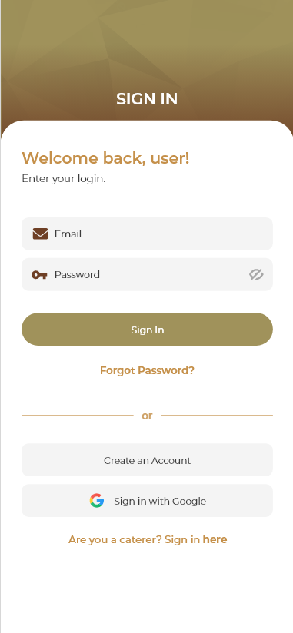
* Signup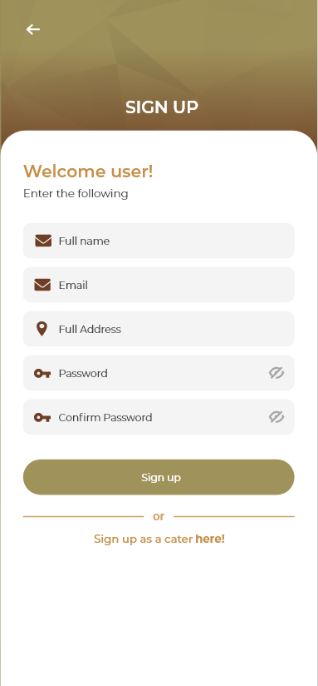
* OTP Screen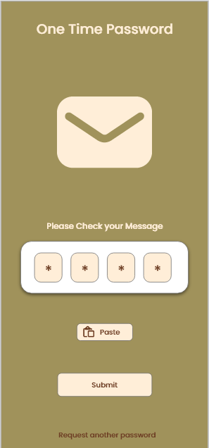
* Home Screen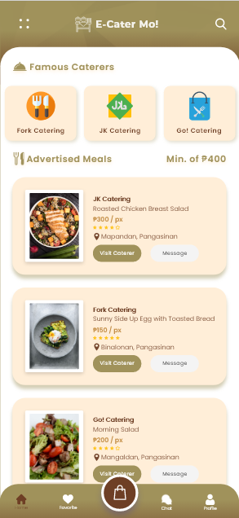
* User Profile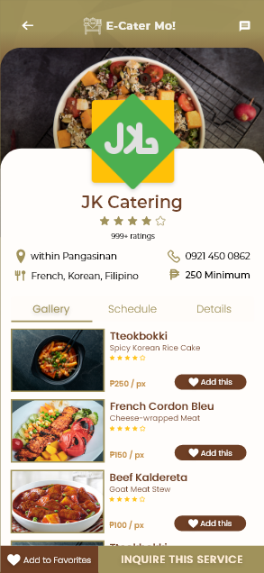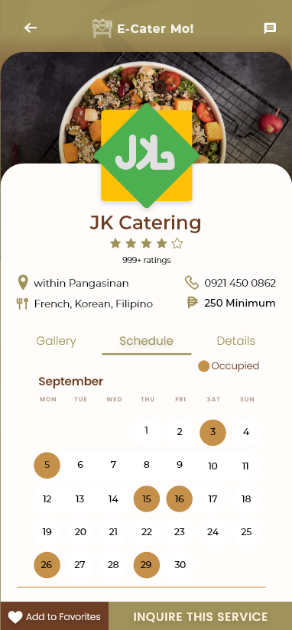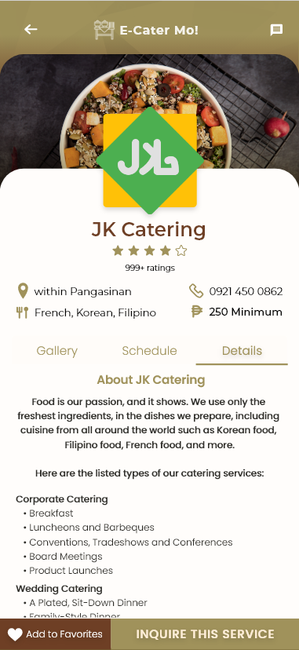
* Profile of the Caterer when clicked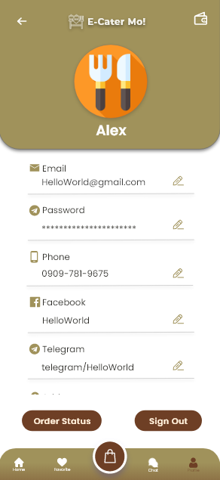
* Full Order Transaction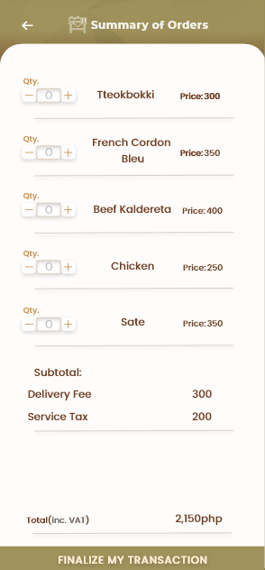
* Order Status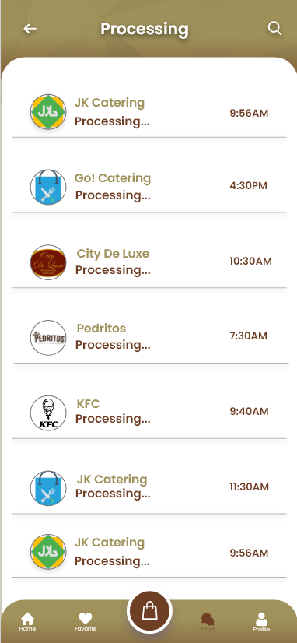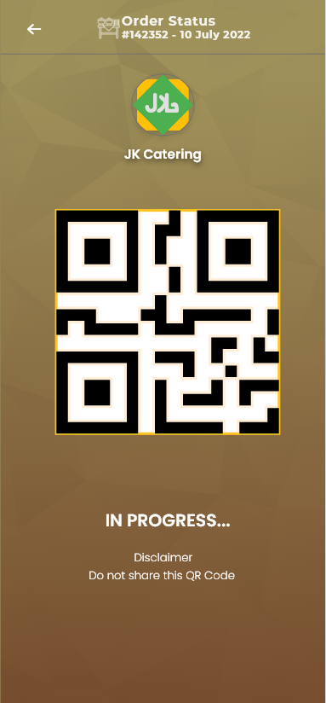
* Message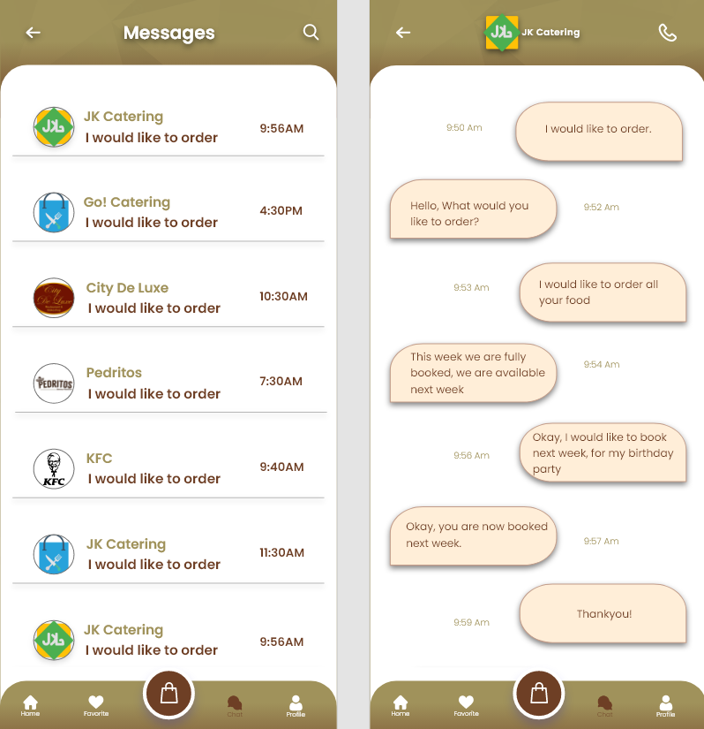
* E-Wallet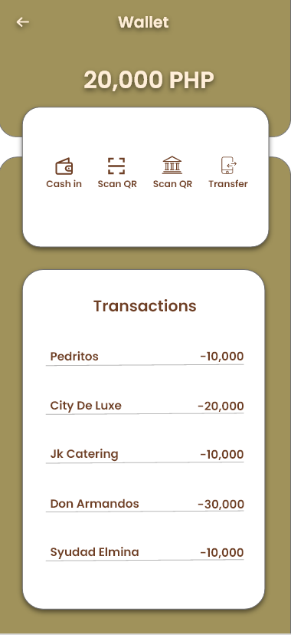
* Feedback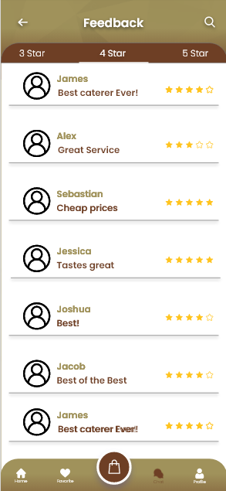
* Order and Schedule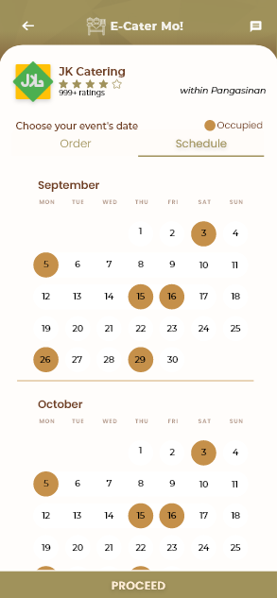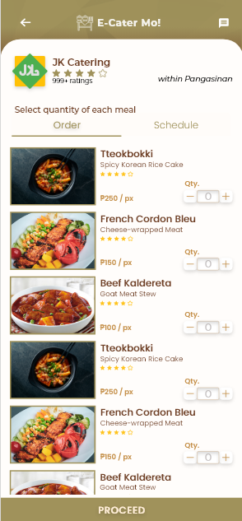
* Verification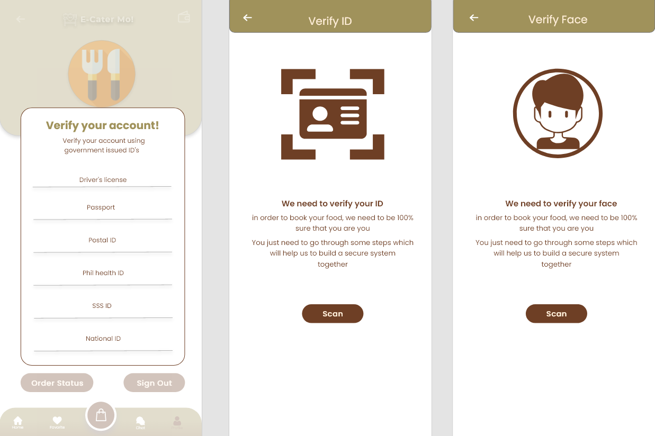

1. **Caterer’s POV** when using the application

* Login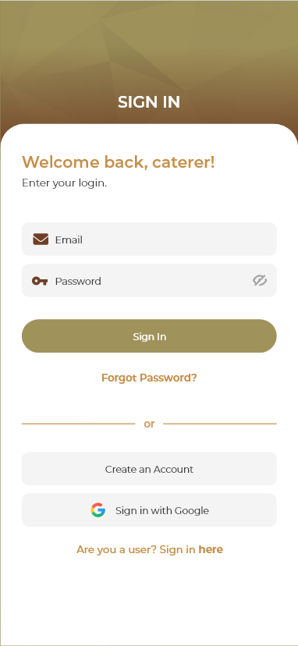
* Signup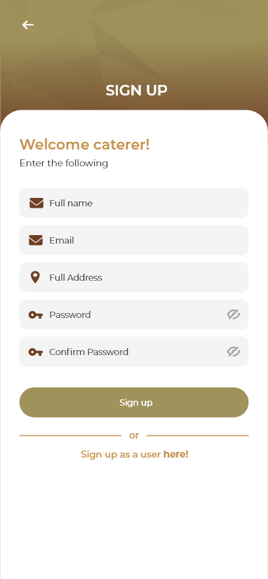
* OTP Screen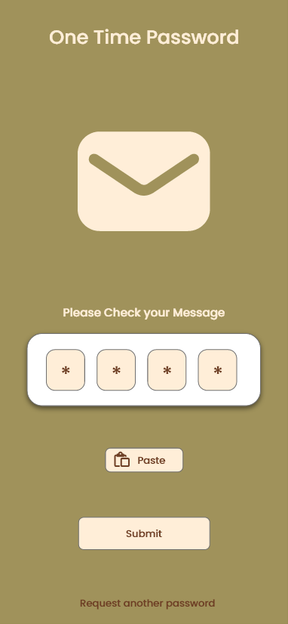
* Home Screen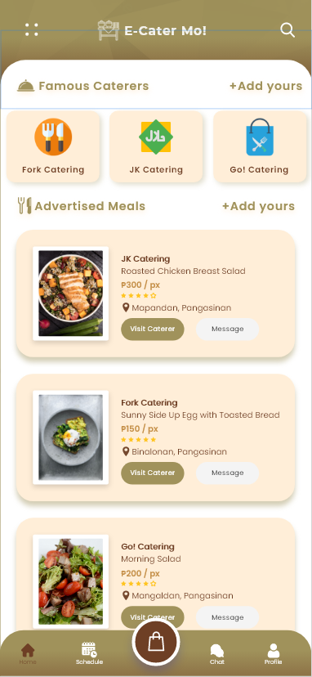
* User Profile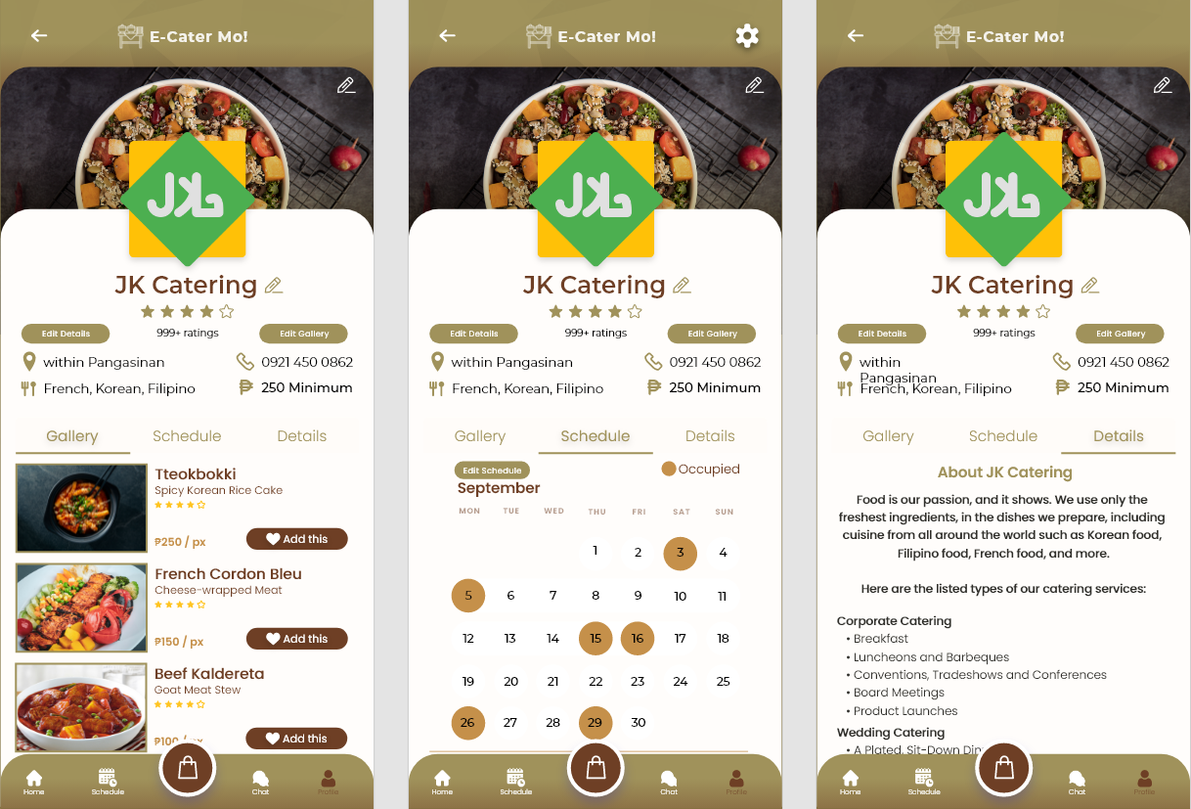
* Order Status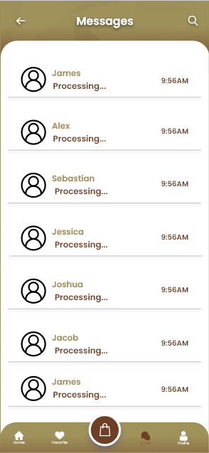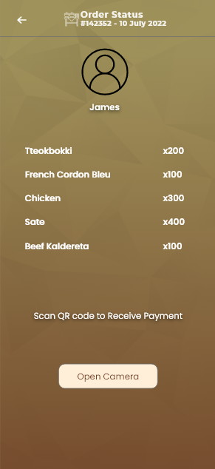
* Message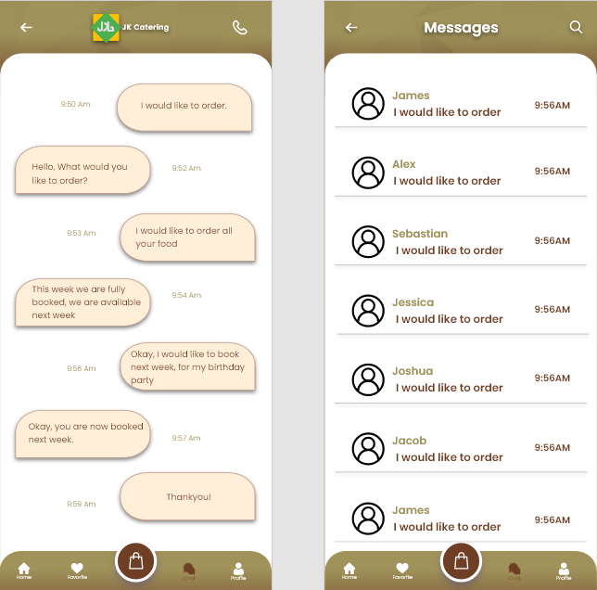
* Profile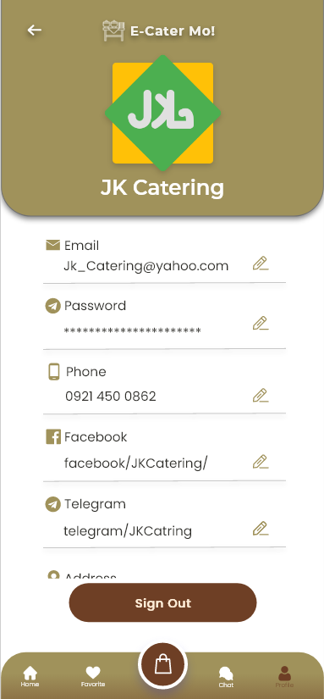
* Verification



**WEBSITE**

1. **Home** 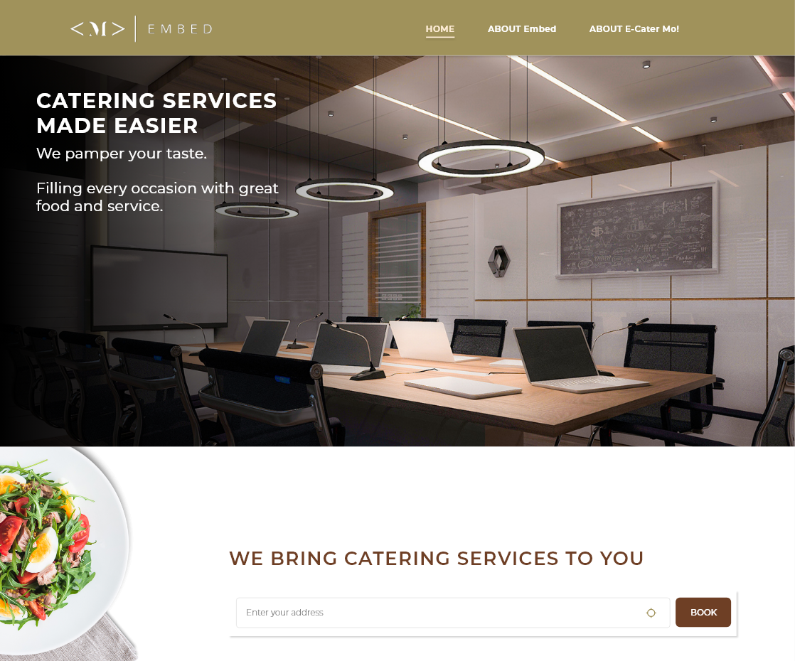

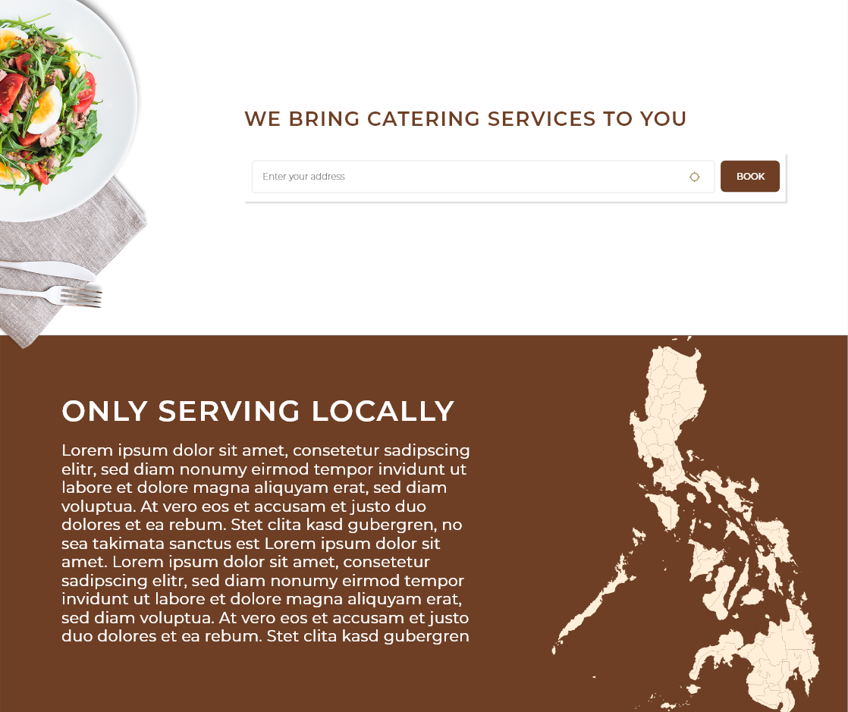

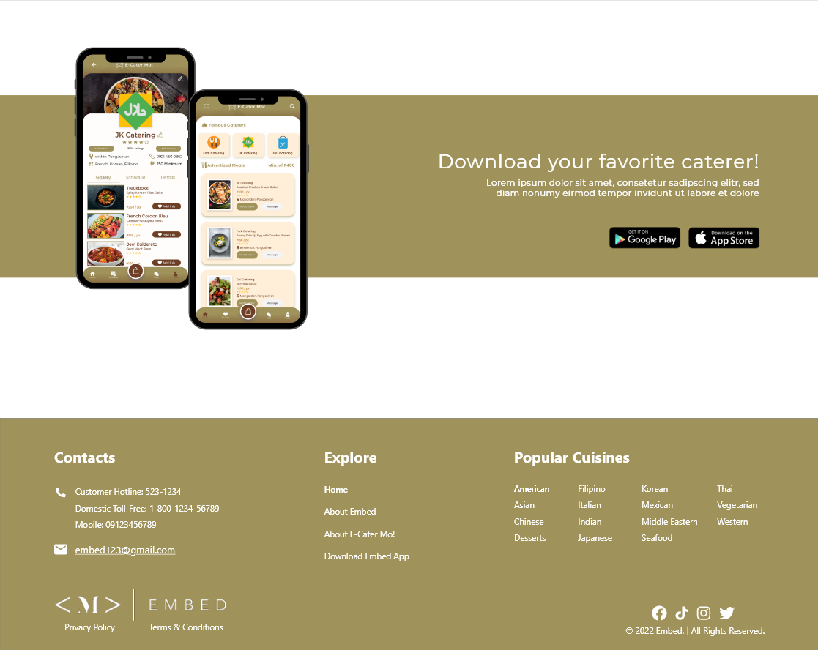

1. **About EMBED**

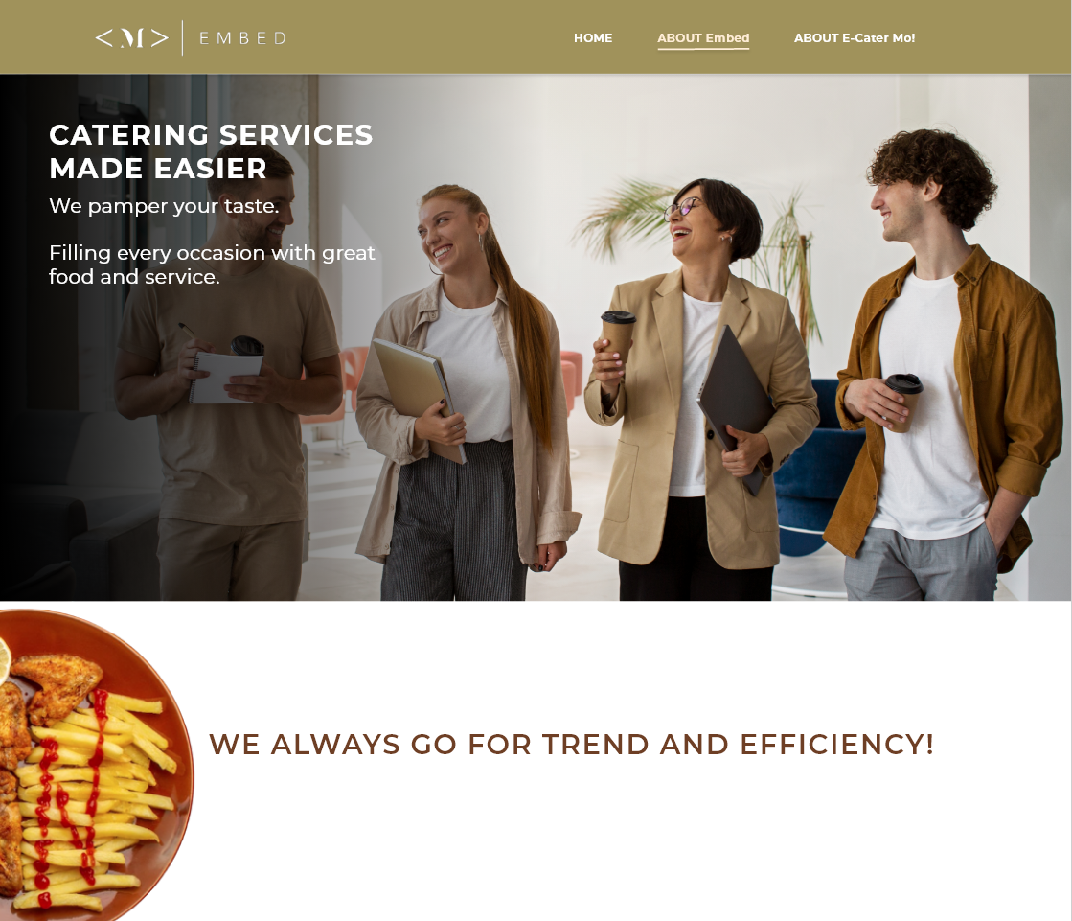

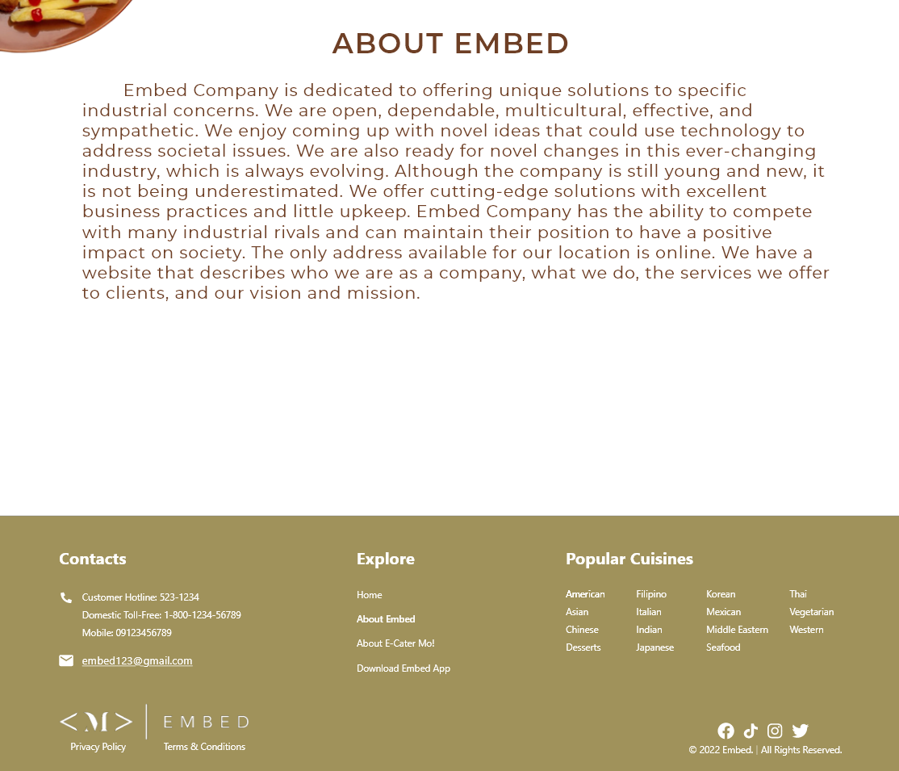

1. **About E-Cater Mo!**

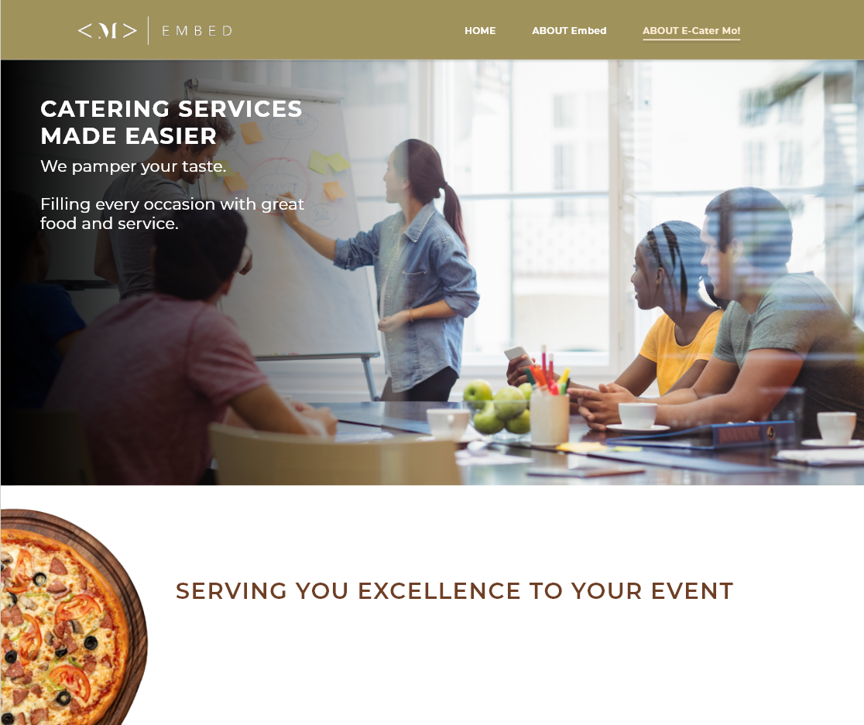

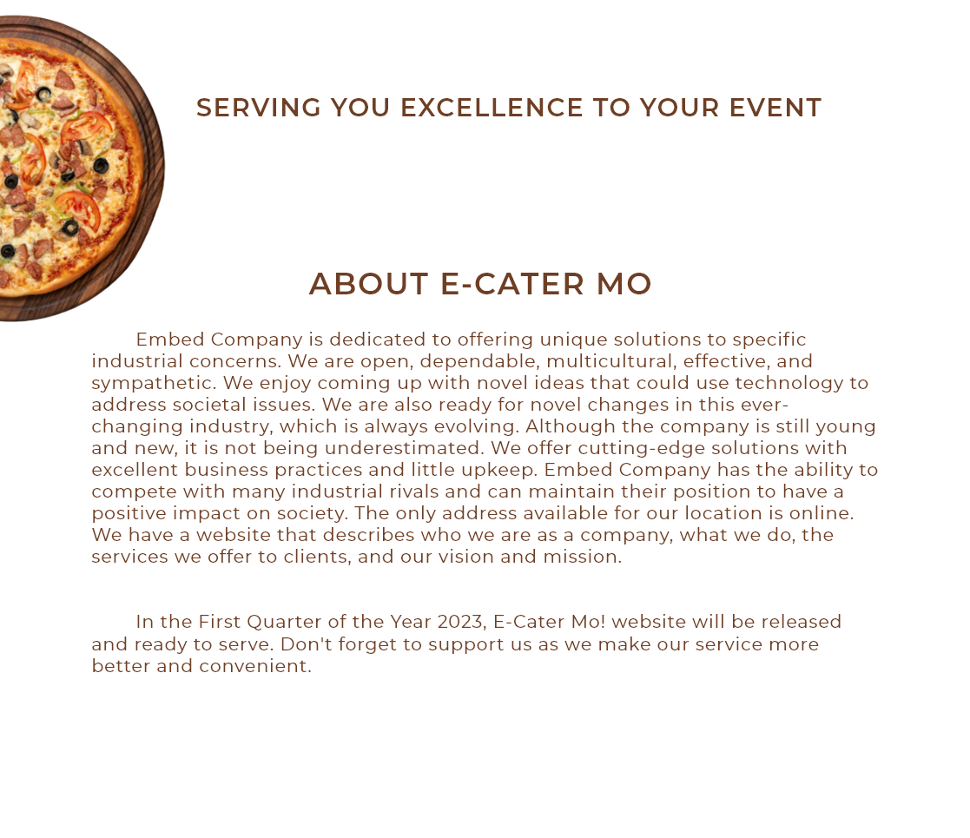

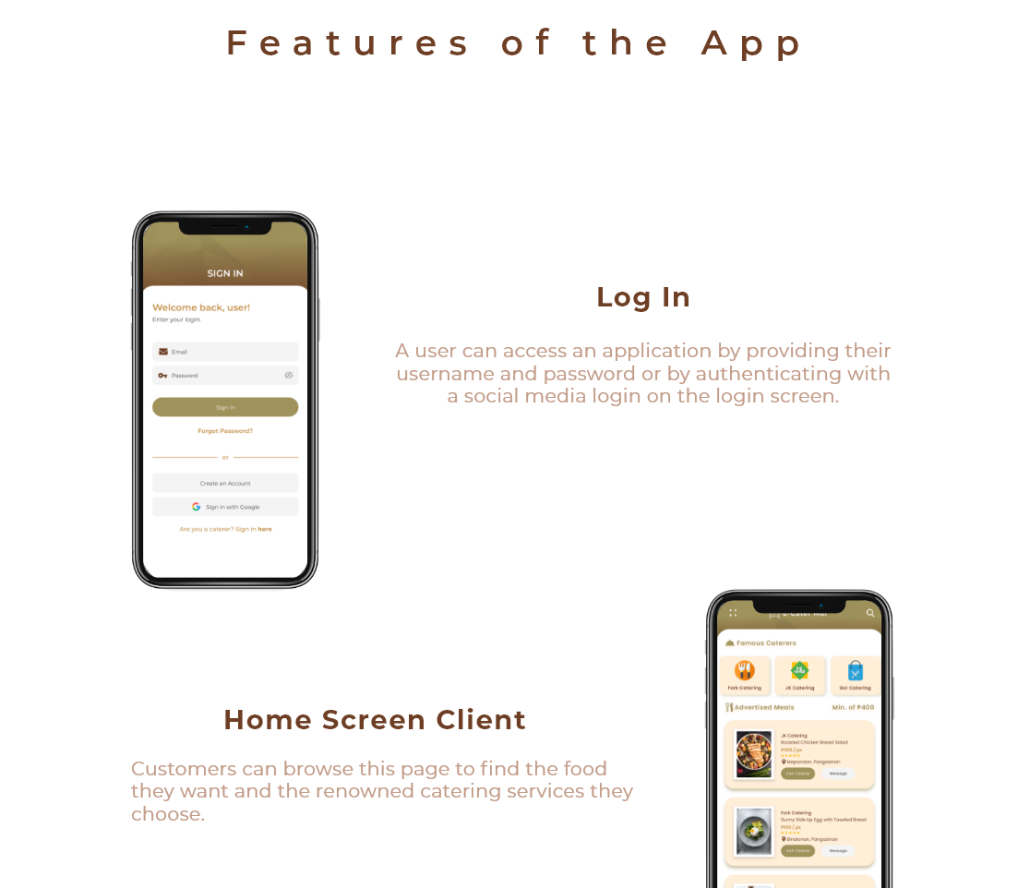

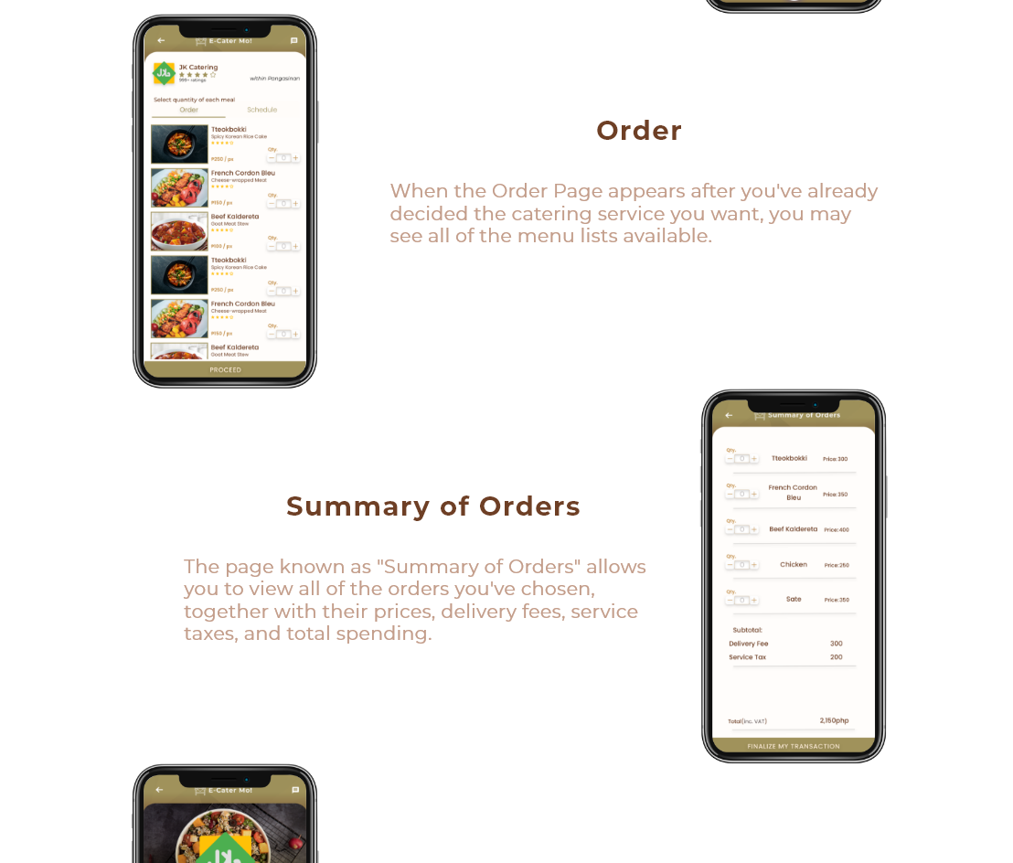

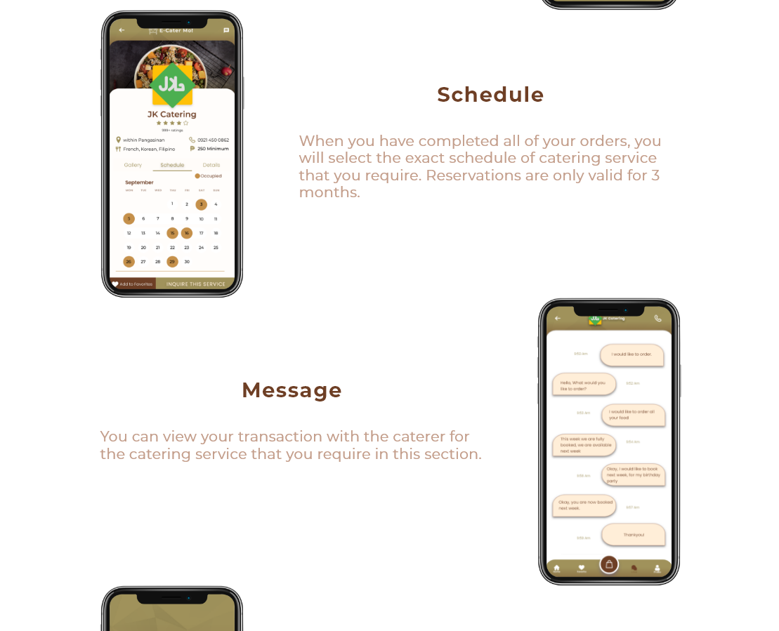

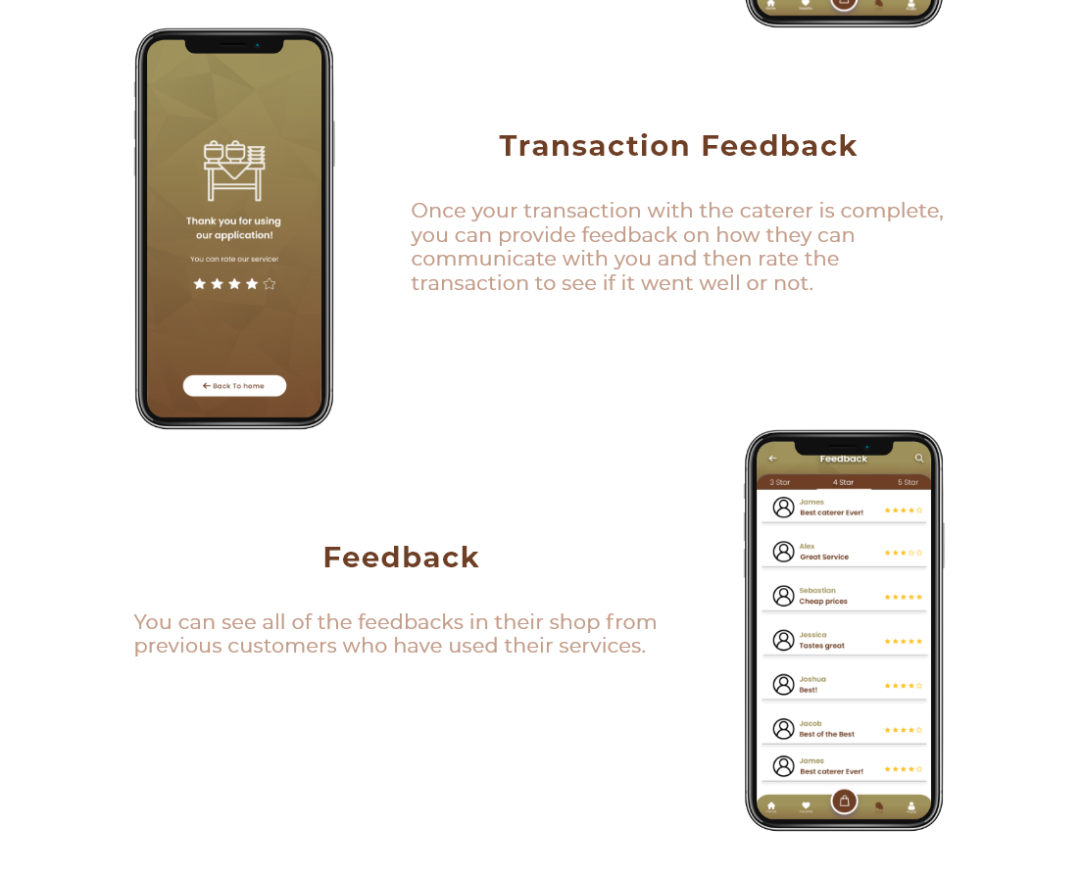

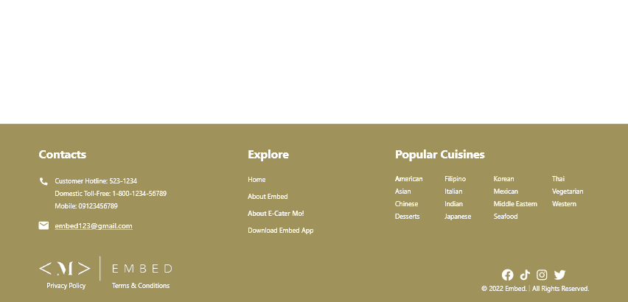

## MANAGEMENT TEAM

As a company expands, entrepreneurs and business owners could find it difficult to manage many high-level responsibilities. This could comprise the overall business plan of the entire company's accounting, marketing, and sales departments. A crucial step in growing a business is assembling a management team to assist in assigning roles and duties. A management team is a collection of senior employees that a business owner has employed to handle crucial duties within the company.

**Figure 1. Management Team Roles**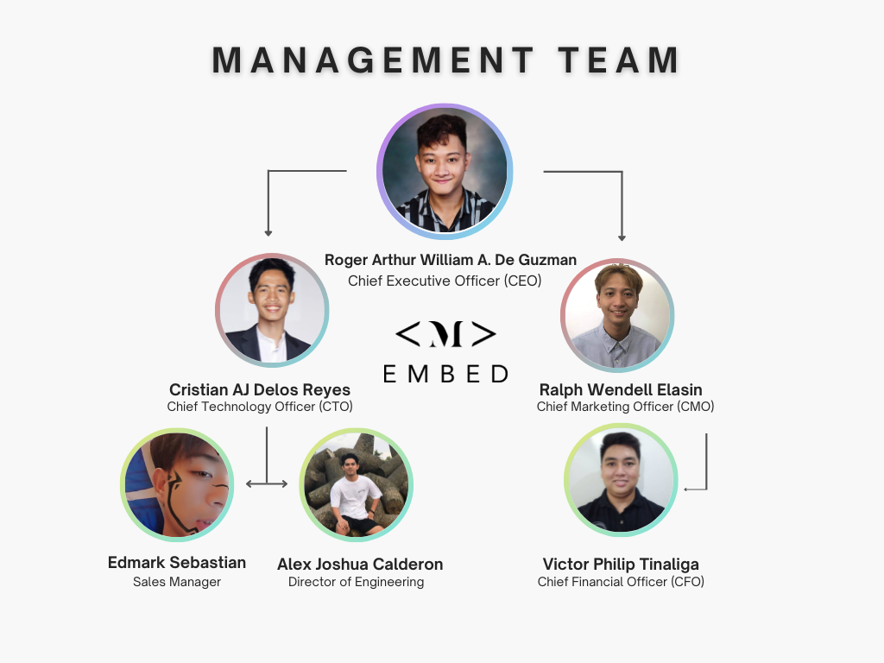

**Project Venture:** E-Cater Mo!

**Founders:**

1. Roger Arthur William A. De Guzman
2. Cristian AJ Delos Reyes
3. Ralph Wendell Elasin
4. Victor Philip Tinaliga
5. Edmark Sebastian
6. Alex Joshua Calderon

**Employees Roles and Responsibilities**

| **Name of Employee/Founder** | **Role** | **Job Description** |
| --- | --- | --- |
| De Guzman, Roger Arthur William Alejo | Chief Executive Officer (CEO) | The CEO is typically the big-picture person who controls the company’s direction, vision, and culture. |
| Calderon, Alex Joshua | Director of Engineering | The Engineering director is responsible for recruiting qualified Employees to whom they assign and designate tasks in an organization and inspect the development and maintenance of staff abilities and suitability and this sector is also where the production is created. |
| Delos Reyes, Cristian AJ | Chief Technology Officer (CTO) | The CTO is responsible for developing, implementing, managing and evaluating the company's technology resources. |
| Elasin, Ralph Wendell Maramba | Chief marketing officer (CMO) | A Chief Marketing Officer is responsible for overseeing the planning, development and execution of an organization's marketing and advertising initiatives. They play a vital role in a company's growth and have important responsibilities that range from creative influence to business strategy. |
| Sebastian, Edmark | Sales manager | Sales managers are responsible for leading sales teams to reach sales targets. Sales managers are primarily tasked with hiring and training team members, setting quotas, evaluating and adjusting performance, and developing processes that drive sales. |
| Tinaliga, Victor Philip | Chief financial officer (CFO) | The Chief Financial Officer directs a company's financial goals, objectives and budgets. If you work as a CFO, you oversee the investment of funds held by the company and assess and manage associated risks. |

## OVERALL SCHEDULE

We have a schedule in place for sharing information about our chronological plan as we construct E-Cater Mo.

Figure 1. Overall Schedule Plan

| **Year when you plan to open a business** | **Date** | **Target Output/Milestone** |
| --- | --- | --- |
| When do you plan to define and plan a business vision? | September 27, 2022 | Dates and the person or team responsible is complete |
| Target completion date of prototypes? | December 16, 2022 | Prototype of the System is done |
| Date when you plan your business plan outlined? | January 2023 | Business Plan Outlined Completed by this date |
| When do you plan to established  website and application? | April 2023 | Website/Application system is done |
| When do you plan to obtain your critical financing? | September 2023 | Planning Critical Financing is Done by this date |
| When do you plan to incorporate a Venture? | February 2023 | EMBED system is incorporated |
| Date to test your EMBED system product concept? | November 2023 | Test to ensure its viability of the system, product been tested with a target customers |
| Date when you plan to launch the soft opening of your business | December 9, 2024 | Opening of EMBED system for business, successfully launch by this date |

## OPERATIONS PLAN

The whole business plan for our organization is illustrated in the following figure in terms of the entire system flow process.

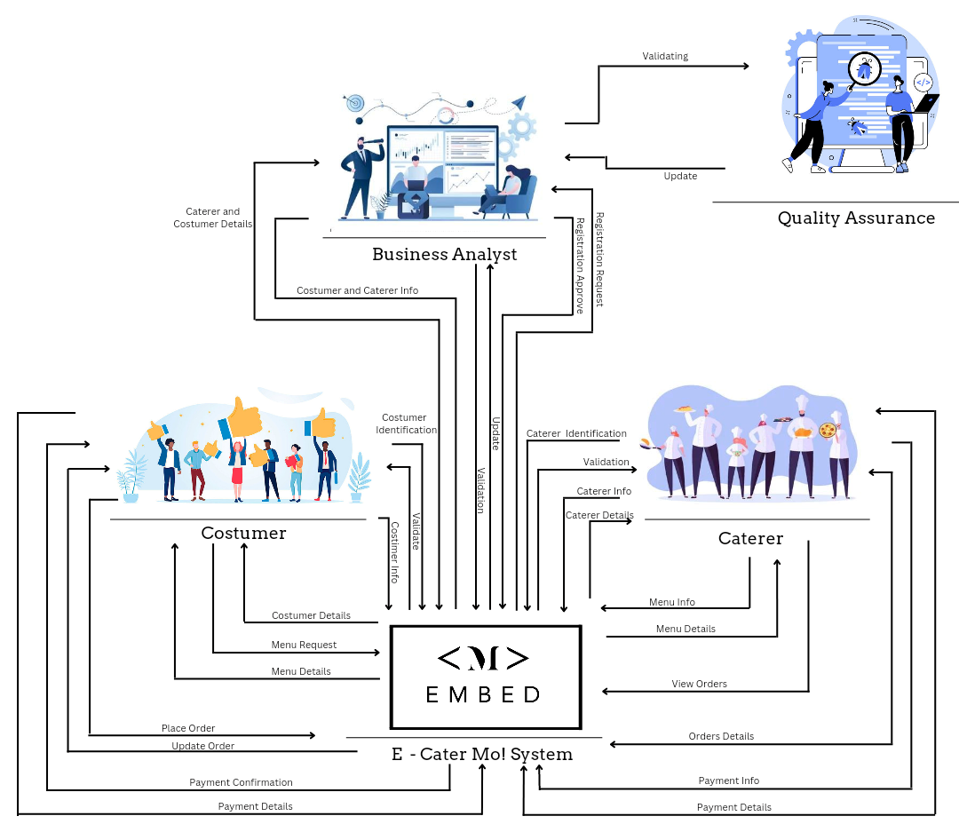

## FINANCIAL PROJECTIONS

Target Sales are presumably 15% above total costs. Sales are to grow by 3% every year, therefore the cost of sales grows proportionally. Since we are dealing with a lot of electricity keeping the servers online, the electricity bills are supposed to grow as the cost of sales grow.

Depreciation expenses are those expenses incurred to account for equipment usage throughout the years. Our supercomputers are useful for up to 5 years from now before getting maintenance. The accountant used the most common generic depreciation method which is the straight line method.

|  |  |  |  |
| --- | --- | --- | --- |
| **Pro Forma Income Statement** | | | |
| Target Sales* |  |  | 1,611,708.00 |
| Cost of Sales** |  |  | (718,000.00) |
| Gross Profit |  |  | 893,708.00 |
| Less: Operating Expenses |  |  |  |
|  |  | Advertising Expense | (15,000.00) |
|  |  | Depreciation Expense** | (72,000.00) |
|  |  | Graphic Design Subscriptions Expense | (22,800.00) |
|  |  | Document Software Subscription Expense | (23,760.00) |
|  |  | Social Media Advertisements | (3,400.00) |
|  |  | Help Desk Salaries | (180,000.00) |
|  |  | Admin Salaries | (300,000.00) |
|  |  | Electricity*** | (180,000.00) |
|  |  | Landline/Internet | (20,000.00) |
| Operating Income |  |  | 76,748.00 |
|  |  |  |  |
| *Target Sales is set to be 5% above total costs |  |  |  |

|  |  |  |
| --- | --- | --- |
| **BREAKDOWN OF COST OF SALES\*\*** | | |
| *Website Maintenance Fee* |  |  |
|  | Domain Name | 1,000.00 |
|  | Web Hosting | 9,000.00 |
|  | SSL Certificate | 57,000.00 |
| Total Website Maintenance Fee |  | 67,000.00 |
|  |  |  |
| Mobile Maintenance Fee |  |  |
|  | Servers | 24,000.00 |
|  | Push Notifications | 5,000.00 |
|  | Payment Gateways | 68,000.00 |
|  | Database | 20,000.00 |
| Total Mobile Maintenance Fees |  | 117,000.00 |
|  |  |  |
| Wages of laborers and programmers |  |  |
|  | Website Developers | 138,000.00 |
|  | Mobile Application Developers | 276,000.00 |
|  | Tech Support | 120,000.00 |
| Total Wages of laborers & programmers |  | 534,000.00 |
|  |  |  |
| Total Cost of Sales |  | 718,000.00 |
|  |  |  |

**Figure 3**

| Pro Forma Income Statement | | | Growth % | 2023 | 2024 | 2025 | 2026 | 2027 |
| --- | --- | --- | --- | --- | --- | --- | --- | --- |
| Target Sales* |  | 1,765,204.00 | 3% | 1,818,160.12 | 1,872,704.92 | 1,928,886.07 | 1,986,752.65 | 2,046,355.23 |
| Cost of Sales |  | (718,000.00) | 3% | (739,540.00) | (761,726.20) | (784,577.99) | (808,115.33) | (832,358.79) |
| Gross Profit |  | 1,047,204.00 |  | 1,078,620.12 | 1,110,978.72 | 1,144,308.09 | 1,178,637.33 | 1,213,996.45 |
| Less: Operating Expenses |  |  |  |  |  |  |  |  |
|  | Advertising Expense | (15,000.00) | 0 | - | - | - | - | - |
|  | Depreciation Expense** | (72,000.00) | Fx | (72,000.00) | (72,000.00) | (72,000.00) | (72,000.00) | (72,000.00) |
|  | Graphic Design Subscriptions Expense | (22,800.00) | Fx | (22,800.00) | (22,800.00) | (22,800.00) | (22,800.00) | (22,800.00) |
|  | Document Software Subscription Expense | (23,760.00) | Fx | (23,760.00) | (23,760.00) | (23,760.00) | (23,760.00) | (23,760.00) |
|  | Social Media Advertisements | (3,400.00) | Fx | (3,400.00) | (3,400.00) | (3,400.00) | (3,400.00) | (3,400.00) |
|  | Help Desk Salaries | (180,000.00) | Fx | (180,000.00) | (180,000.00) | (180,000.00) | (180,000.00) | (180,000.00) |
|  | Admin Salaries | (300,000.00) | Fx | (300,000.00) | (300,000.00) | (300,000.00) | (300,000.00) | (300,000.00) |
|  | Electricity*** | (180,000.00) | 0.25 | (184,885.00) | (190,431.55) | (196,144.50) | (202,028.83) | (208,089.70) |
|  | Landline/Internet | **(20,000.00)** | **Fx** | **(20,000.00)** | **(20,000.00)** | **(20,000.00)** | **(20,000.00)** | **(20,000.00)** |
| **Operating Income** |  | **230,244.00** |  | **271,775.12** | **298,587.17** | **326,203.59** | **354,648.50** | **383,946.75** |
|  |  |  |  |  |  |  |  |  |
| ASSUMPTIONS: |  |  |  |  |  |  |  |  |
| The company aims to set sales to grow at 3% per year. The company have no plans increasing fixed operating costs within the 5-year financial projections |  |  |  |  |  |  |  |  |
| *Target Sales is set to be 5% above total costs |  |  |  |  |  |  |  |  |
| **Depreciation expense derives from Equipment totalling P360,000.00 with 5 useful years |  |  |  |  |  |  |  |  |

# RAISING CAPITAL

Embed company is a new start-up company providing services using technology. Since the majority of the costs are intangible, raising capital won't be a significant challenge. The following strategies to raise money for our project are listed below:

| **List down atleast 3 plans to raise a capital for your venture** | **How do you plan to execute it?** |
| --- | --- |
| Bootstrapping | Since we are studying IT, it is expected that we would have our own resources, such as laptops or desktop computers and knowledge of software creation. To cut costs, we'll also use free, open-source, or community-driven technologies, solutions, and APIs. Additionally, we shall ask our clients for payments in advance. |
| Investors | We might be able to raise money by presenting our business plan proposal to our investors. To raise money to start up a capital for our venture charges, we need to attract investors as well as stakeholders. |
| Friends and Family | We firmly think that our family and friends will be the first to stand with us. No matter what your business outcome, they are always there. We are able to approach our wealthy family for a loan to use as startup cash. As a gift from them, we might also ask for a financial contribution. |

**GoFundMe**

PROS:

● No deadlines or goal limits.

● Not all or nothing funding.

● Fees are the same whether you get fully or partially funded.

CONS:

● No guarantee of success.

● Must meet withdrawal requirements.

● Limited customer service options.

**Indiegogo**

PROS:

● Not all or nothing funding.

● All kinds of projects are accepted for fundraising on the site.

● There can be a lot of donors.

CONS:

● Fees can be higher.

● A lot of competition for the attention of the donor.

● Lower average funds were raised than some other crowdfunding sites.

# NEW AGE SOURCES OF INCOME

| **NEW AGE SOURCE INCOME** | **HOW DO YOU PLAN TO USE IT?** | **WHAT WILL BE ITS IMPACT TO YOUR BUSINESS?** |
| --- | --- | --- |
| ADVERTISEMENTS | Since our service functions as an e-commerce platform for the catering industry, selecting advertising as one of the main new age sources of income will benefit from stability in our service economy. We intend to roll out our technology, giving caterers the choice of using it to promote their catering company or their goods. | The practice of using advertisements to promote one's business on a platform is standard in business. It will significantly affect preserving our economics and the consistency of our service. Catering companies will take advantage of every advertising opportunity they come across, and we will profit from that for sure. |
| SPONSORS | We are willing to accept sponsorship from anyone who wants to support our young, expanding firm. This will raise the effectiveness and motivation of our business, particularly with regard to our service, E-Cater Mo. | Although sponsorships won't have much of an effect on our business, they will inspire and motivate my other co-founders and other team members. It is just meant for individuals who enjoy supporting our efforts and hope to see our product better in the future. |
| DONATIONS | We like to make our business available for donations, much like with sponsorships. We included GoFundMe and Indiegogo as one of our raising capitals on our business. Users can send their donations here. | The economy of our business is not considerably impacted by donations, but they will still aid in our efforts to raise money and revenue. Users who have good intentions and hearts can freely express themselves by giving. In this way, it can support our motivation and confidence as we continue to expand as a business. |

# FEASIBILITY ANALYSIS

Risk exists in all business undertakings to some extent. The value of prospective hazards is evaluated through feasibility studies. Real business possibilities can be distinguished from potentially risky investments through a thorough feasibility study.

**Part 1: Strength of the Business Idea**

| AREAS | De Guzman, Roger Arthur William Alejo | Calderon, Alex Joshua | Delos Reyes, Cristian AJ | Elasin, Ralph Wendell Maramba | Sebastian, Edmark | Tinaliga, Victor Philip |
| --- | --- | --- | --- | --- | --- | --- |
| 1. Extent to which the idea:  * Takes advantage of an environmental trend * Solves a problem * Addresses an unfilled gap in the marketplace | 1  (High) | 1  (High) | 1  (High) | 1  (High) | 1  (High) | 1  (High) |
| 1. Timeliness of entry to market | 1  (High) | 1  (High) | 1  (High) | 1  (High) | 1  (High) | 1  (High) |
| 1. Extent to which the idea adds value for its buyer or end user | 0  (Moderate) | 0  (Moderate) | 0  (Moderate) | 0  (Moderate) | 0  (Moderate) | 0  (Moderate) |
| 1. Extent to which the customer is satisfied by competing products that are already available | 0  (Moderate) | 0  (Moderate) | 0  (Moderate) | 0  (Moderate) | 0  (Moderate) | 0  (Moderate) |
| 1. Degree to which the idea requires customers to change their basic practices or behaviors | 1  (High) | 1  (High) | 1  (High) | 1  (High) | 1  (High) | 1  (High) |
| Total | 3 | 3 | 3 | 3 | 3 | 3 |
| Score | 3 | | | | | |

**Part 2: Industry Related Issues**

| AREAS | De Guzman, Roger Arthur William Alejo | Calderon, Alex Joshua | Delos Reyes, Cristian AJ | Elasin, Ralph Wendell Maramba | Sebastian, Edmark | Tinaliga, Victor Philip |
| --- | --- | --- | --- | --- | --- | --- |
| 1. Number of Competitors | -1  (Low) | -1  (Low) | -1  (Low) | -1  (Low) | -1  (Low) | -1  (Low) |
| 1. Stage of Industry life cycle | 1  (High) | 1  (High) | 1  (High) | 1  (High) | 1  (High) | 1  (High) |
| 1. Growth rate of industry | 1  (High) | 1  (High) | 1  (High) | 1  (High) | 1  (High) | 1  (High) |
| 1. Importance of industry’s products and/or services to customers | 1  (High) | 1  (High) | 1  (High) | 1  (High) | 1  (High) | 1  (High) |
| 1. Industry operating margins | 1  (High) | 1  (High) | 1  (High) | 1  (High) | 1  (High) | 1  (High) |
| Total | 4 | 4 | 4 | 4 | 4 | 4 |
| Score | 3.33 | | | | | |

**Part 3: Target Market and Customer-Related Issues**

| AREAS | De Guzman, Roger Arthur William Alejo | Calderon, Alex Joshua | Delos Reyes, Cristian AJ | Elasin, Ralph Wendell Maramba | Sebastian, Edmark | Tinaliga, Victor Philip |
| --- | --- | --- | --- | --- | --- | --- |
| 1. Identification of target market for the proposed new venture | 1  (High) | 0  (Moderate) | 1  (High) | 0  (Moderate) | 1  (High) | 1  (Hig |
| 1. Ability to create “barriers to entry” for potential competitors | 0  (Moderate) | 0  (Moderate) | 0  (Moderate) | 0  (Moderate) | 0  (Moderate) | 0  (Moderate) |
| 1. Purchasing power of customers | 1  (High) | 0  (Moderate) | 0  (Moderate) | 1  (High) | 1  (High) | 1  (High) |
| 1. Ease of making customers aware of the new product or service | 1  (High) | 1  (High) | 1  (High) | 1  (High) | 1  (High) | 1  (High) |
| 1. Growth potential of target market | 1  (High) | 1  (High) | 1  (High) | 1  (High) | 1  (High) | 1  (High) |
| Total | 4 | 2 | 3 | 3 | 4 | 4 |
| Score | 3.33 | | | | | |

**Part 4: Founders’ Related Issues**

| AREAS | De Guzman, Roger Arthur William Alejo | Calderon, Alex Joshua | Delos Reyes, Cristian AJ | Elasin, Ralph Wendell Maramba | Sebastian, Edmark | Tinaliga, Victor Philip |
| --- | --- | --- | --- | --- | --- | --- |
| 1. Founder’s or founders’ experience in the industry. | 0  (Moderate) | 0  (Moderate) | 0  (Moderate) | 0  (Moderate) | 0  (Moderate) | 0  (Moderate) |
| 1. Founder’s or founders’ skills as they relate to the   proposed new venture’s product or service | 1  (High) | 0  (Moderate) | 0  (Moderate) | 0  (Moderate) | 0  (Moderate) | 0  (Moderate) |
| 1. Extent of the founder’s or founders’ professional and social networks in the relevant industry | 0  (Moderate) | -1  (Low) | 0  (Moderate) | -1  (Low) | 0  (Moderate) | 0  (Moderate) |
| 1. Extent to which the proposed new venture meets the founder’s or founders’ personal goals and aspirations | 1  (High) | 1  (High) | 0  (Moderate) | 1  (High) | 1  (High) | 0  (Moderate) |
| 1. Likelihood that a team can be put together to launch and grow the new venture | 1  (High) | 1  (High) | 1  (High) | 1  (High) | 1  (High) | 1  (High) |
| Total | 3 | 1 | 1 | 1 | 2 | 1 |
| Score | 3.16 | | | | | |

**Part 5: Financial Issues**

| AREAS | De Guzman, Roger Arthur William | Calderon, Alex Joshua | Delos Reyes, Cristian AJ | Elasin, Ralph Wendell Maramba | Sebastian, Edmark | Tinaliga, Victor Philip |
| --- | --- | --- | --- | --- | --- | --- |
| 1. Initial capital investment | 1  (High) | 1  (High) | 1  (High) | 1  (High) | 1  (High) | 1  (High) |
| 1. Number of revenue drivers (ways in which the company makes money) | 0  (Moderate) | 0  (Moderate) | 0  (Moderate) | 0  (Moderate) | 0  (Moderate) | 0  (Moderate) |
| 1. Time to break even | 1  (High) | 0  (Moderate) | 0  (Moderate) | 0  (Moderate) | 0  (Moderate) | 0  (Moderate) |
| 1. Financial performance of similar businesses | 0  (Moderate) | 0  (Moderate) | 0  (Moderate) | 0  (Moderate) | 0  (Moderate) | 0  (Moderate) |
| 1. Ability to fund initial product (or service) development and/or initial start-up expenses from personal funds or via bootstrapping | 1  (High) | 1  (High) | 1  (High) | 1  (High) | 1  (High) | 1  (High) |
| Total | 3 | 2 | 2 | 2 | 2 | 2 |
| Score | 2.16 | | | | | |

**Overall Potential Table**

The following table below provides the total and summarization of all members’ evaluation in each part of the feasibility analysis. It includes scores, overall potential businesses idea (high, moderate, low) and suggestions for improving the potential

| **Parts** | **Score (-5 to +5)** | **Overall Potential of the Businesses Idea Based on Each Part**  **(High, Moderate, Low)** | **Suggestions for Improving the Potential** |
| --- | --- | --- | --- |
| Part 1: Strength of Business Idea | 3 | HIGH | To attract more customers, stay current on social and technological trends. |
| Part 2: Industry-Related Issues | 3.33 | HIGH | Should outwit rivals to secure a piece of the new market. |
| Part 3: Target Market and Customer Related Issues | 3.33 | HIGH | Maintain this score, but do market research to raise it in order to find target consumers and ward off potential competitors. |
| Part 4: Founder’s (or Founders’) Related Issues | 3.16 | HIGH | Attend training sessions and seminars to increase your knowledge and skill set. |
| Part 5: Financial Issues | 2.16 | HIGH | To accelerate reaching the break even faster, add new revenue generators. |
| Overall Assessment | 3.164 | HIGH | DevSign is practical because it has High Potential, but it could want some improvement in certain areas to keep running. |

# CONCLUSION

E-Cater Mo is a mobile app for online food catering services that strives to succeed in the food services industry. Our startup can compete with other companies that are in a similar industry. Additionally, E-Cater Mo has put a lot of emphasis into Financial Projections in particular. Our goal is to cater our service to the needs and wants of our clients. Our business venture will generate and construct a very satisfactory investment return each year, and we are extremely convinced about this.

We may conclude that E - Cater Mo based on the information and evaluation we have provided above. will be a prosperous company. We have internal resources like development expertise, graphic design know-how, and testing tools like desktop/laptop, PCs, and mobile phones.

We form relationships with other caterers in order to raise money for our upcoming system update in return for advertising and expanding their catering operations.

In order to ensure that the company is well-known to clients, our business will continue to focus on business strategies and customer service, especially in terms of marketing. We anticipate being able to develop a solid and devoted consumer base every year.